Honors Educational Reach Out
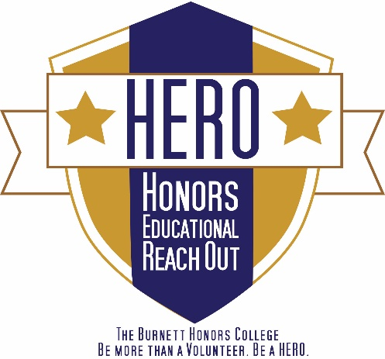
ORMC / UF Health Cancer Center Volunteer Packet

The Burnett Honors College has long been known for providing quality instruction in our classrooms and laboratories so that our honors graduates are prepared for rich and productive lives in the workplace. We have now expanded our educational horizons so that our students are well educated for citizenship as well as for careers. As a public institution of higher learning, UCF is committed to strong partnerships with the Orlando area public schools and nonprofit organizations. We endorse that commitment and have established exciting service opportunities for our students so they will grow as socially responsible young women and men to understand the importance of being civically engaged.

HEROs help the ORMC and UF Health teams by serving as liaisons between patients, their families and hospital team members, by assisting pharmacists and pharmacy technicians, by sharing their talents through the Healing Arts Program, by distributing patient educational materials and resources, and much more. Volunteering at Orlando Health is a great way to explore careers in the medical field, while giving back to the Central Florida community.

Contact Information:

HERO Program Assistants  Jasmine Watts  Meleah Davies  orce@ucf.edu  (407)823-0851  BHC 102 | Medical HERO Ambassador  orce@ucf.edu  BHC 102 | ORMC Volunteer Services  Hayley Brown  Asst. Volunteer Services Manager  hayley.brown@orlandohealth.com  UF Health Volunteer Services  Shari Bryant  Asst. Volunteer Services Manager  shari.bryant@orlandohealth.com
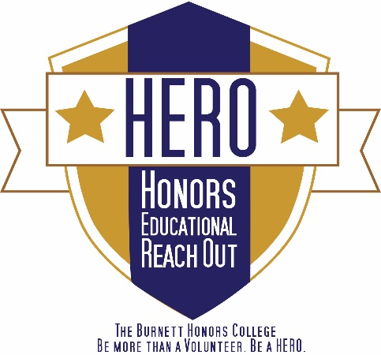
Orlando Health – ORMC/UF Health Checklist
- Fill out the online ORMC/UF Health Adult Volunteer Application (write that you are with the HERO Program in the comment area of the “Education” section of the app) and email the HERO office to confirm that you have done so
- Attend your ORMC/UF Health volunteer interview to get your personal volunteer assignment (day, time, area)
- Complete TB/Drug Screening
- Attend the Volunteer Orientation assigned to you during your interview
- Email the HERO office the following information:
- the day and time you will be volunteering at the hospital each week
- your personal volunteer assignment (area of the hospital in which you will be volunteering)
- Register for a Knight Connect Service Hours Tracker account
- Request to join the “Orlando Regional Medical Center and UF Health Cancer Center” Facebook groups and keep up with updates
- Complete 25 volunteer sessions (100 hours) at ORMC/UF Health over duration of being a student
- Record hours in the Knight Connect Service Hours Tracker

VOLUNTEER RESPONSIBILITIES

- Commit to volunteer on a specific day and time for 4 hours on a weekly basis. This is a yearly commitment. You are expected to complete at least 25 volunteer sessions. Students must complete a minimum of 100 hours during their time as a UCF student.
      - Attend all scheduled volunteer sessions with the exception of illness or emergencies.
  - Please cancel if you are sick! You are volunteering in a hospital.
  - If you have to cancel, email the volunteer office (PG-ORMCvolunteerservices@orlandohealth.com) at least 24 hours in advance.
  - If you call (321)-841-5379 to cancel and are directed to a voicemail, make sure you include the following information:
    - Your full name
    - The fact that you are a HERO volunteer from UCF
    - The purpose for the call
    - A phone number where you can be reached
    - Sample Message: “This is Fred Jones, one of your HERO volunteers from UCF. I am scheduled to volunteer Friday from 12:00 to 4:00; however, I have the flu and will not be able to make it. I will be in next week at my regularly scheduled time. Sorry for the inconvenience. If you need to reach me, please call 407-888-8888.”
- Provide your own transportation to your volunteer site
  - If you do not have your own transportation, we will try to find someone for you to travel with; however, a carpool is not guaranteed
  - You will be given an Orlando Health Parking Decal free of charge
  - There is no need for you to ever pay for parking, even before you get your Orlando Health Parking Decal
- Check-in and -out each time you volunteer on the computer in the Volunteer Services office, then report to your service area. If you are volunteering at an “off-campus” location, you will have a separate process that will be explained at your orientation.
- Keep track of the hours you volunteer using Knight Connect Service Hours Tracker account after each volunteer session.
  - You must join the organization before you can use the Hours Tracker
  - Your Username will be created by you
  - Your Password will be created by you
- Treat this like a part-time job.
  - Although these are unpaid volunteer positions, ORMC/UF Health is putting in a lot of time, money and training to make sure this is a positive experience for you.
  - Please make sure that you update them on any changes in your contact information and fill out the Leave of Absence Form with proper notice
KNIGHT CONNECT HOURS TRACKER
Keep track of the hours you volunteer using KNIGHT CONNECT online Service Hours Tracker https://ucf.collegiatelink.net/organization/orce/events after each volunteer session. You must join the organization before you can use the Service Hours Tracker component.
- When logging your hours, you can include travel time.

APPLICATION PROCESS
Forms
- The following forms need to be turned in to the HERO Coordinator in BHC room 102:
  - Signed Honors Educational Reach Out Volunteer Agreement
  - Confirmation that you submitted the online Orlando Regional Medical Center Adult Volunteer Application (use your current, Orlando address)
https://www.volgistics.com/ex/portal.dll/ap?AP=2046920201&OR=1
    - Write that you are with the HERO program in the comment area of the “Education” section of the app
    - Provide 3 references: one professional (i.e. professor, employer), and two personal (i.e. roommate, fellow student organization member). Your references’ email addresses are required.
- Applications are pulled each Monday, so it may take up to two weeks for you to be contacted. Please be patient.

Interview & Scheduling
- You will be contacted to schedule an interview once your references and background check have been cleared. At your interview you will:
  - discuss volunteer opportunities available at the hospital
  - be assigned a Volunteer Orientation date
  - Schedule Tuberculosis test
  - have your picture taken for your ID badge
- Finalize your volunteer details with the volunteer services team and email the HERO office:
  - the day and time you will be volunteering at the hospital each week
  - your personal volunteer assignment (the area of the hospital in which you will be volunteering and what you will be doing)
- Dress for the interview is business casual

Orientation
- One Volunteer Orientation will be held at The Burnett Honors College at the beginning of fall and spring semesters if needed
- Regularly scheduled Volunteer Orientations are held 2-3 times per month at ORMC
- On average, ORMC / UF Health Volunteer Orientations run 2 ½ to 3 hours

Testing
- All volunteers must pass tuberculosis and drug/alcohol screenings
  - The tuberculosis test is a blood-draw and the drug screen is a urine sample. If you have completed a TB test within the last 30 days, you may submit this paperwork to occupational health at your appointment
  - These screenings should be completed before you attend orientation
  - The volunteer office will try to coordinate scheduling your interview Call (321)841-5212 to schedule your appointments. The Testing Center is open between 7:30am – 4:00pm Mon-Fri

PROFESSIONALISM

You are representing UCF, The Burnett Honors College, and the HERO program. Make sure to dress appropriately and maintain a professional demeanor. This experience will prepare you for future interviews and will familiarize you with proper workplace etiquette.

ORMC Volunteer Uniform
What to Wear:  - Red polo, provided by ORMC  - Orlando Health ID badge  - Slacks or khakis  - Closed-toe closed-heel shoes (sneakers recommended) | What Not to Wear:  - T-shirts, sweatshirts  - Jeans, shorts  - Flip-flops, high-heels  - Hats, sunglasses  - Excessive jewelry
Facial piercings are to be removed or concealed. Tattoos need to be hidden by clothing, not bandages. Do not wear perfume, because some patients are allergic.

Demeanor
All electronic equipment (i.e. cell phones, iPods, etc.) should be turned off and stored while you are volunteering. Do not use inappropriate and/or obscene language and no smoking while you are on hospital grounds.

Email Etiquette
When emailing the ORMC Volunteer office, make sure you include the following information:
- Your full name
- The fact that you are a HERO volunteer from UCF
- The purpose for the email
- The best way (email/phone) and time to contact you
- Make sure you are using your appropriate Knights email account!

Sample Email:
Dear Ms. Smith,
My name is Fred Jones and I am a HERO volunteer from UCF. I would like to know what days and times work best for you to have me come in. I am free on Fridays and after 3:00 Monday through Thursday. Please email me back at fred_jones@knights.ucf.edu or you can call me at 407-888-8888. I look forward to working with you.
Sincerely,
Fred Jones
Phone Etiquette
If you are directed to a voicemail, remember it is always better to give too much information rather than not enough. Make sure you include the following information:
- Your full name
- The fact that you are a HERO volunteer from UCF
- The purpose for the call
- A phone number and a good time to call you
- Make sure your voicemail message is appropriate.
Sample Message: “This is Fred Jones, a HERO volunteer from UCF. I am calling to discuss a time when we can meet. Please give me a call at 407-888-8888. I can be reached at this number most afternoons. Thank you.”
Sample Voicemail: “You have reached the voicemail of Fred Jones. I am not available to take your call at this time. Please leave your name and number, and I will call you back as soon as possible.”
VOLUNTEER BENEFITS
- Free reserved parking
- A free meal for each four-hour shift you work (and a 30 minute break to eat it!)
- Free flu shots
- Discounts to area restaurants and movie theaters
- Semi-annual volunteer recognition events

DIRECTIONS TO ORMC
4000 Central Florida Blvd. Orlando, FL 32816

- Take University to the 417 South
- Take a slight left to get onto the 408 West
- Take exit 11A toward Rosalind Ave/Hospital
- Turn left onto E South St
- Turn left onto S Orange Ave
- Turn right onto Columbia St
- Turn left onto Kuhl Ave

52. West Underwood Street, Orlando FL 32806
When you reach Underwood street the visitor parking garage is on the left hand side and ORMC is straight ahead.

ORMC/UF Health Volunteer Opportunity Descriptions

*The volunteer positions above may not be available at the time that you apply. For an updated list of the positions that currently need to be filled, visit http://www.orlandohealth.com/orlandohealth/volunteerwithus/ServiceAreas.aspx?pid=3563 for ORMC’s available service areas and http://www.orlandohealth.com/orlandohealth/volunteerwithus/ServiceAreas.aspx?pid=3558 for the UF Health Cancer Center’s available service areas.

Patient Access
Volunteers who serve with this department will assist with patients who are first registering for their stay at the hospital. After the patient is registered, the care ambassador in this department will guide the patient to his/her destination in the hospital. This is an excellent assignment for volunteers that would like to move throughout the hospital.

Guest Services
The Guest Services team serves as a liaison between patients and hospital staff and they are responsible for ensuring that patient and guest needs are consistently met. Care ambassadors who serve with the Guest Services team will assist with a variety of duties. Responsibilities may include greeting, directing and escorting guests around the different areas of the hospital, as well as answering guest inquires. These assignments are located in the emergency room, surgical floor, trauma waiting room and the lobby.

Inpatient/Outpatient Rehabilitation
The rehabilitation team includes physiatrists, certified rehab RN’s , physical therapists, occupational therapists, speech language pathologist, registered dieticians, neuropsychologists, recreational therapists and social workers who collaborate to assist each patient in the meeting their individualized rehabilitation goals. These areas offer a great experience for students interested in rehabilitation.

Oshibori
Volunteer Services offers a daily relaxing hot towel, or Oshibori, experience to all of the hospital’s patients, guests, and team members free of charge. With the added element of aromatherapy, Oshibori is a unique way to not only cleanse the hands, but experience a moment of comforting tranquility. Patients often put the towels directly on their heads or necks to ease their pain and stress. This is a great assignment for care ambassadors who want to volunteer among patients all throughout the hospital.

Art and Music Care Ambassador
For volunteers who posess talent for art of music, Orlando Health has opportunities for them to utilize their skills. If you play an instrument or even like to do arts and crafts, please inquire about this opportunity.

Nursing Unit Volunteer
The function and goal of this service is to provide a warm and caring touch to patients and their family members while being hospitalized. It also allows teamwork with the nursing staffs of various floors, including surgical, orthopedic, cardiology, primary medicine, neurology and the intensive care unit. Work is scheduled seven days a week with flexible hours.

Non Clinical Areas
There are many areas in the hospital that do not directly involve patient care but are vital to the hospitals operation. These areas are also in need of help and give the volunteers unique experience. These areas include but are not limited to: Pharmacy, Food and Nutrition, Conference Services and Centray Supply.

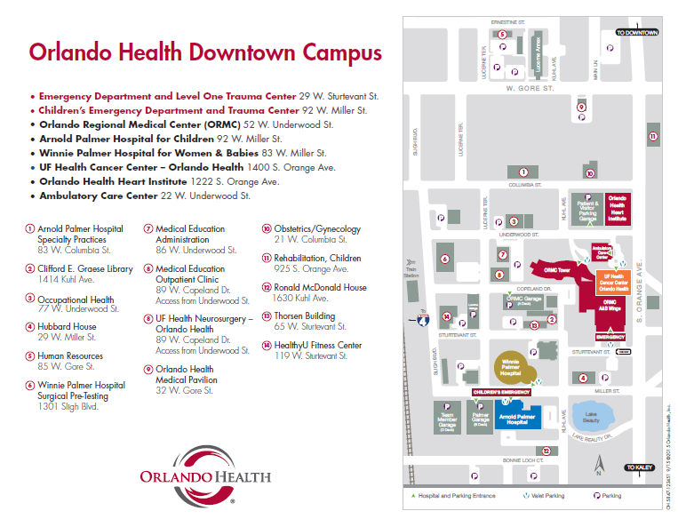

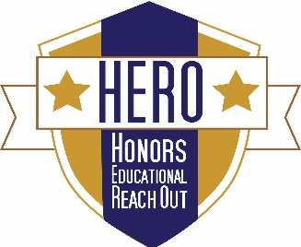
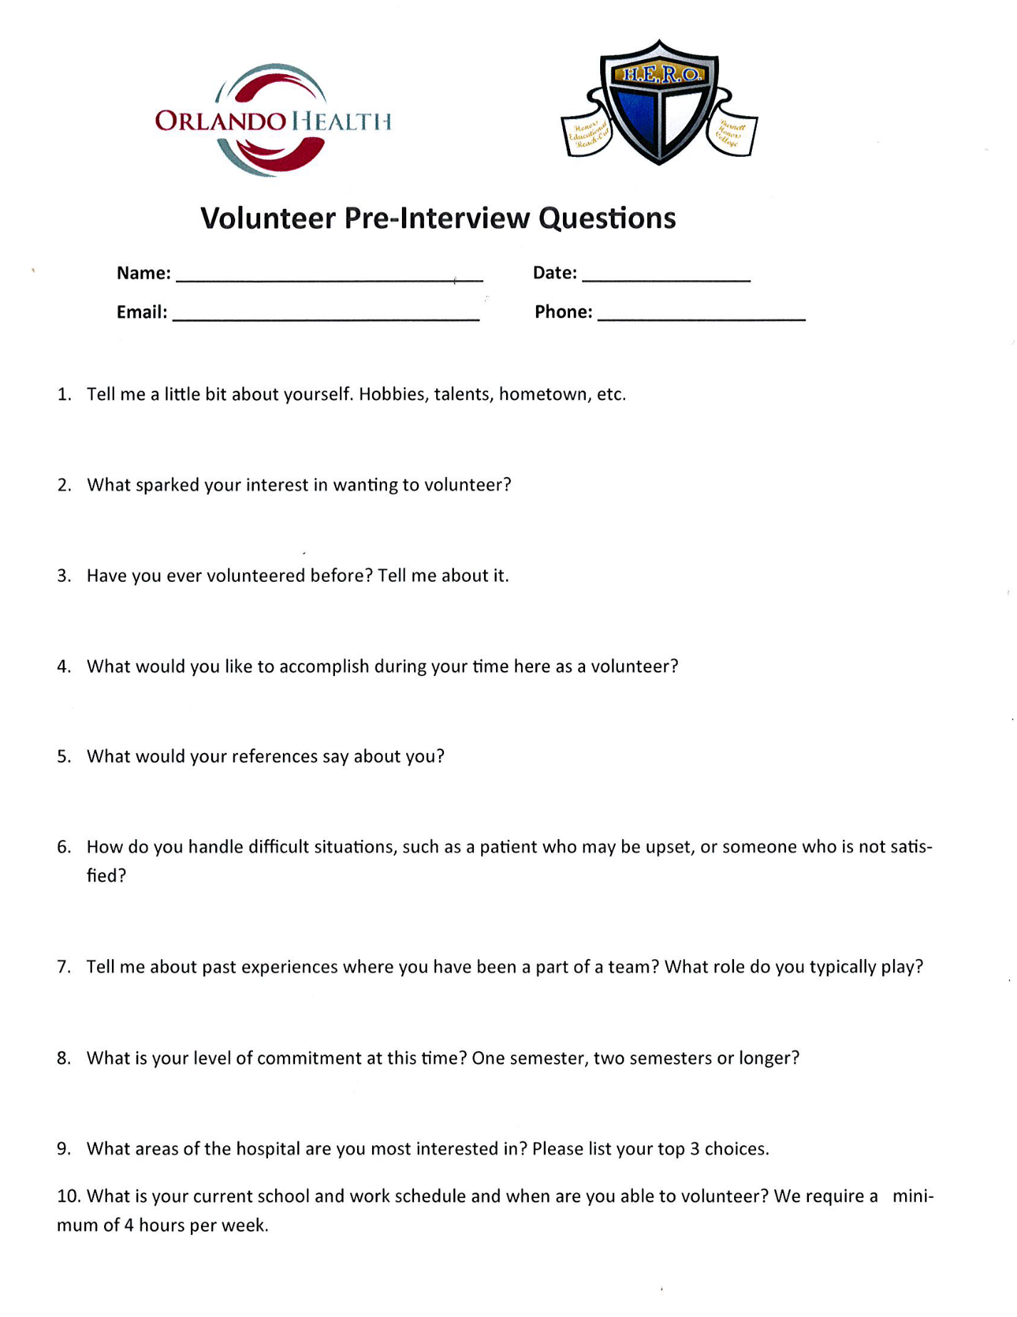

Honors Educational Reach Out Volunteer Agreement
Orlando Regional Medical Center (ORMC)

I, _________________________, have read, understand, and accept the roles and responsibilities of being a Honors Educational Reach Out (HERO) Orlando Regional Medical Center volunteer. I also understand that by volunteering for the Honors Educational Reach Out program sponsored by The Burnett Honors College at the University of Central Florida, I am assuming any and all risks associated with my participation. This includes, but is not limited to, transportation, be it provided by myself or another volunteer, and any physical or mental harm that may result from my activities under this program.
I agree to comply with the rules and regulations of the University of Central Florida and Orlando Regional Medical Center, and I take full responsibility for my actions as a HERO program volunteer. I likewise agree to follow the schedule established in connection with this volunteer opportunity. I am aware of the roles and responsibilities of this agreement.

Volunteer’s Signature _______________________________________ Date _______________
Volunteer’s Printed Name _______________________________________
UCF ID (PID) ___________________________ Phone ____________________________
KnightsMail __________________________________________________________________
Year Started College________ Major_________________________ Honors? y/n___________
Transportation____________________ Would you be willing to carpool?_________________

