Honors Educational Reach Out
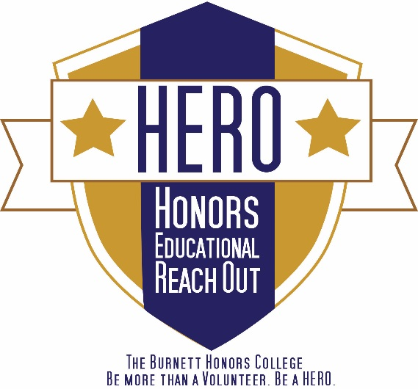
Green HEROs Volunteer Packet

The Burnett Honors College has long been known for providing quality instruction in our classrooms and laboratories so that our honors graduates are prepared for rich and productive lives in the workplace. We have now expanded our educational horizons so that our students are well educated for citizenship as well as for careers. As a public institution of higher learning, UCF is committed to strong partnerships with the Orlando area public schools and nonprofit organizations. We endorse that commitment and have established exciting service opportunities for our students so they will grow as socially responsible young women and men to understand the importance of being civically engaged.

Green HEROs help make Central Florida a cleaner, greener, more beautiful place. They volunteer for organizations such as Green-Up Orlando, Keep Orlando Beautiful and the Seminole Education, Restoration and Volunteer (SERV) Program, which hold events geared toward improving the environment. Green HEROs work with other civic organizations, neighborhood associations, schools and businesses on tree plantings, park clean-ups, waterway clean-ups, recycling efforts and many other environmental projects. Participating in Green HEROs is a great way to enhance the Central Florida community, and get a little exercise at the same time.
HERO Program Assistants
Jasmine Watts
Meleah Davies
orce@ucf.edu
(407)823-0851
BHC 102

Contact Information:

HERO Ambassador
orce@ucf.edu
BHC 102

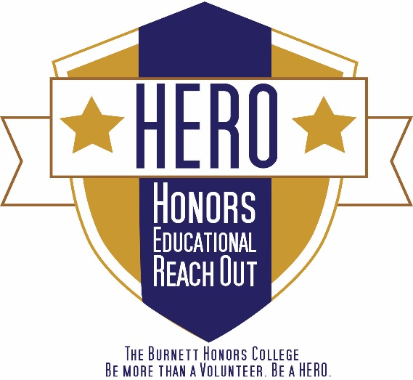
Green HEROs Checklist
- Turn in the Green HEROs Volunteer Agreement to the HERO office (BHC 102)
- Sign up for a Green HEROs Event on Knight Connect
- Turn in the SERV Adult Release Form to the HERO office (BHC 102)
- Respond to “Green HEROs Events” emails to sign up for additional events
- Register for a Knight Connect Service Hours Tracker account
- Add HERO on social media at facebook.com/HEROUCF, twitter.com/UCFHERO, Instagram.com/bhchero
- Volunteer at least two Green HEROs event
- Record hours in the Knight Connect Service Hours Tracker

VOLUNTEER RESPONSIBILITIES

- Commit to volunteer at a minimum of 2 events per semester
- Attend all events you sign-up for with the exception of illness or emergencies
  - Contact the HERO office ASAP if you need to cancel
  - If you call to cancel and are directed to a voicemail, make sure you include the following information:
    - Your full name
    - The fact that you are a Green HEROs volunteer
    - The purpose for the call
    - A phone number where you can be reached
    - Sample Message: “This is Fred Jones, one of your Green HEROs volunteers. I am signed-up to volunteer this Saturday at the Green-Up Orlando event; however, I have the flu and will not be able to make it. I will email you soon with the date of the make-up event I would like to attend. Sorry for the inconvenience. If you need to reach me, please call 407-888-8888.”
- Carpooling is not guaranteed, but we will work to set up a carpool to each event that will leave from UCF. Make sure you arrive at the meet up location on time!
- Check-in with the Event Leader each time you volunteer. You will receive an email prior to events you sign-up for with the Event Leader’s name and contact information.

KNIGHT CONNECT HOURS TRACKER
Keep track of the hours you volunteer using KNIGHT CONNECT online Service Hours Tracker https://ucf.collegiatelink.net/organization/orce/events after each volunteer session. You must join the organization before you can use the Service Hours Tracker component.
When logging your hours, you can include travel time

APPLICATION PROCESS
Forms
- The following forms need to be turned in to the HERO office in BHC room 102:
  - Signed copy of the Honors Educational Reach Out Volunteer Agreement
  - Completed SERV Adult Release Form

Scheduling
- You can sign-up for events via Knight Connect, or by responding to the “Green HEROs Events” email sent out. “Green HEROs Events” emails may include newly scheduled events not listed on Knight Connect.

PROFESSIONALISM

You are representing UCF, The Burnett Honors College, and the HERO program. Make sure you dress appropriately and maintain a professional demeanor.
Dress
You need to wear clothes you can move in. Make sure your clothes are not too tight (i.e. tank tops), revealing (i.e. sports bras), or unkempt (i.e. excessively baggy or wrinkled). Wear comfortable closed-toe shoes. Bring a water bottle, wear a hat and sunscreen, and prepare to get dirty! If the event requires special instructions on what to wear, instructions will be emailed to the students that signed up for the event.

Demeanor
All electronic equipment (i.e. cell phones, iPods, etc.) should be turned off and stored while you are volunteering. Do not use inappropriate and/or obscene language, and no smoking.

Email Etiquette
When emailing the HERO office, make sure you include the following information:
- Your full name
- The fact that you are a Green HEROs volunteer
- The purpose for the email
- The best way (email/phone) and time to contact you

Sample Email:
Dear Ms. Smith,

My name is Fred Jones and I am a Green HEROs volunteer. I would like to know what clean-up events are taking place in November and December. Please email me back at fred_jones@knights.ucf.edu or you can call me at 407-888-8888. I look forward to hearing from you.

Sincerely,
Fred Jones

Phone Etiquette
If you are directed to a voicemail, remember it is always better to give too much information rather than not enough. Make sure you include the following information:
- Your full name
- The fact that you are a Green HEROs volunteer
- The purpose for the call
- A phone number and a good time to call you
- Make sure your voicemail message is appropriate.
Sample Message: “This is Fred Jones, a Green HERO volunteer. I am calling to discuss a time when we can meet. Please give me a call at 407-888-8888. I can be reached at this number most afternoons. Thank you.”
Sample Voicemail: “You have reached the voicemail of Fred Jones. I am not available to take your call at this time. Please leave your name and number, and I will call you back as soon as possible.”

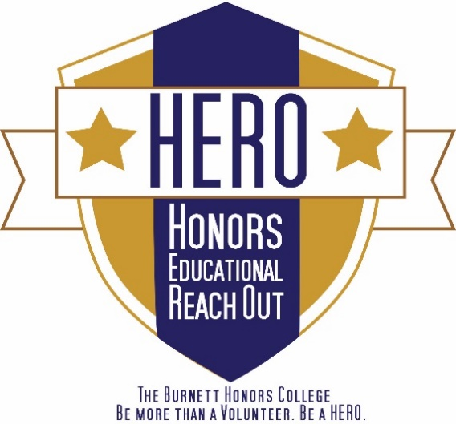

Honors Educational Reach Out Volunteer Agreement
Green HEROs

I, _________________________, have read, understand, and accept the roles and responsibilities of being a Green HEROs volunteer. I also understand that by volunteering for the Honors Educational Reach Out program sponsored by The Burnett Honors College at the University of Central Florida, I am assuming any and all risks associated with my participation. This includes, but is not limited to, transportation, be it provided by myself or another volunteer, and any physical or mental harm that may result from my activities under this program.
I agree to comply with the rules and regulations of the University of Central Florida and Green HEROs’ community partners, and I take full responsibility for my actions as a HERO program volunteer. I likewise agree to follow the schedule established in connection with this volunteer opportunity. I am aware of the roles and responsibilities of this agreement.

Volunteer’s Signature _______________________________________ Date _______________
Volunteer’s Printed Name _____________________________ UCF ID (PID) ______________
Phone ________________________ Knightsmail _____________________________________
Year Started College________ Major_________________________ Honors? y/n___________
Can you provide transportation to events? (If yes, how many others can you bring?) ____________________________________________
Are you interested in being an Event Leader? ___________

